 | Innompic Games  innompics.com | 27-30 September 2018  Malaysia  University of Kuala Lumpur

- Annual GLOBAL intellectual contest for visionary innopreneurs
- Showcase of entrepreneurial creativity and smartness
- Creation show that engages both participants and spectators
BIG CHALLENGE 2018 to be addressed by Innompic Teams
Global Innovation Accelerator
Innompic teams will invent a self-sufficient business unit of a Global Innovation Accelerator and develop its business model and entrepreneurial implementation strategies in a spirit of friendly and joyful constructive competition.
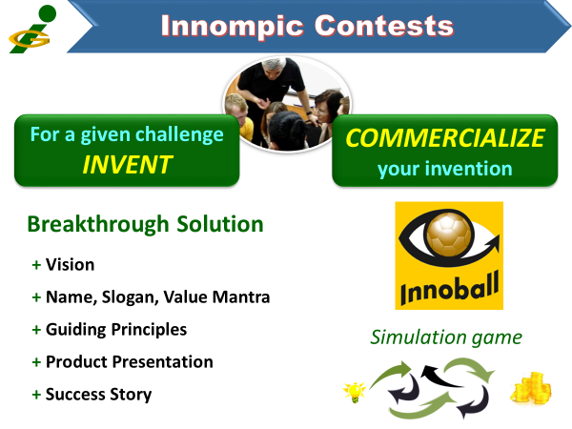
INNOMPIC CONTESTS
Home work: Innompic teams invent a breakthrough solution, develop a business model, an envisaged success story, and a presentation of their venture. → Example
Venture Presentations
Innompic teams make a presentation of their innovative solution and the envisaged success story.
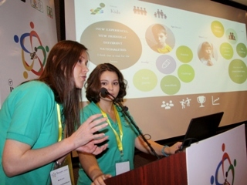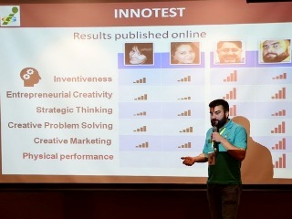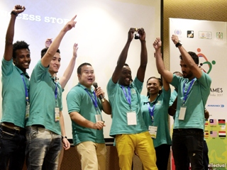
Simulation games
Innompic teams play entrepreneurial simulation game INNOVATION FOOTBALL jointly with each solution to make the solution stronger and demonstrate teams’ entrepreneurial smartness and creativity.
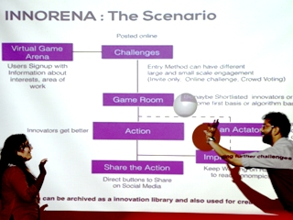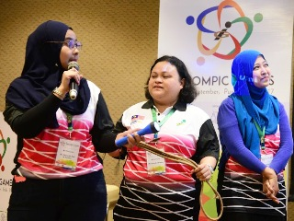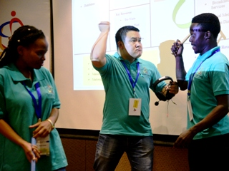
Awards
There are no losers, everyone wins in Innompic Games. Yet, outstanding performers win Innompic awards in various categories (→ Example).
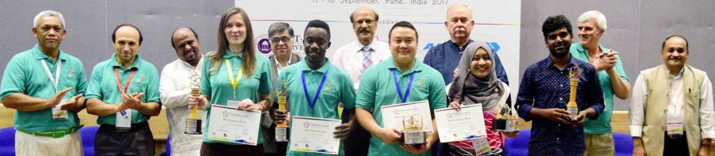
Team awards: Best Innovation Team, Inventiveness, Entrepreneurial Strategies. Anticipation, Creative Problem Solving, Creative Marketing, Intellectual Teamwork
Individual awards: Mister / Miss Innovation World, Best Innovator, Most Brilliant Ideas, Entrepreneurial Leader, Best Actor / Actress, Wittiest Innovator, Best Judge and Innovation Guru, Special awards
Major Results of the 1st Innompic Games 2017
- All participants from 12 countries said it had been an eye-opening event; they learned a lot about how to invent, develop a high-growth business, anticipate challenges, solve problems creatively, and boost intellectual teamwork
- Several participants strengthened their own startups dramatically, while some others got great jobs thanks to what they’d learned during Innompic Games.
- Some great performers got funding for their startups from local agencies.
- Requests for organizing global, regional and industry-specific Innompic Games were received from various countries and organizations → Example
- Great mass media coverage enthused millions of people
New Benefits for the Participants of the 2nd Innompic Games 2018
- Become an early adopter of the World-changing Innompic Games that are to engage over 1 billion people by 2020
- Join the vibrant community of world-changers and fast-growing global Innompic Ecosystem at an early stage and become a leader in your preferred area
- Get privileged access to breakthrough Innompic innovative thinking tools and teaching materials, such as “Outstanding Innopreneur”
- Gain an opportunity to become a member of the International Innompic Committee (IIC) and/or establish a local/industry-specific Innompic Committee
Key Participants
INNOMPIC TEAMS are cross-functional innovation teams of 5-10 people (→ Example)
JUDGES & INNOVATION GURUS are experienced innovators and teachers
Actators are active spectators willing to showcase their entrepreneurial smartness.
Observers are senior representatives of associated organizations.
Contacts

